Basic knowledge assignment

**Gemaakt door:** Tim Chermin

**Versie:** 1.2

**Datum:** 06/03/2020

Table of Contents

Version 3

Introduction 4

Demo en Test Omgeving 4

Test en Analyse resultaat (Screenshots and explanation of all working solutions, like): 4

Overall Conclusion 4

Reflection 5

My company 6

Security incident management 7

Bibliography 12

Notes for later 13

# Version

|  |  |  |  |  |
| --- | --- | --- | --- | --- |
| **Version** | **Autor** | **Date** | **Changes** | **Time spend** |
| 1.0 | Tim Chermin | 13/02/2020 | * Basic setup | 10 min |
| 1.1 | Tim Chermin | 06/03/2020 | * Firewall setup | 6 hours |
| 1.2 | Tim Chermin | 12/03/2020 | * Security incident management | 5 hours |
| 1.3 | Tim Chermin | 13/03/2020 | * Continuation of the firewall setup | 6 hours |

# Introduction

Before this semester I already had some experience since I did the CSA-course before CSB. I didn’t know much about the defensive side of things though. I really liked style 1 when I did the CSA course, so I decided I will be doing the same for CSB.

In this document, I have documented everything I learned this semester and how I learned it.

My main goal was to learn the basics of the defending site of cyber security. I will try to use as much of the knowledge I gained when following the CSA course in this course.

**A lot of the document is still a work in progress.**

# Demo and teste environment

Build (Implementation details and essential configurations for each basic knowledge theme):

* Threat Analysis
* IP-address plan and network drawing reflecting your own demo network
* Firewall settings and rules necessary
* Secure Network Connections needed
* Secure Remote Access and Management (VPN settings)
* Intrusion Detection rules
* IT monitoring configuration
* User and management accounts for role based access (System security)

# Test and Analyse result (Screenshots and explanation of all working solutions, like):

* Basic functioning of internal and public functionality/services (securely)
* Inbound and outbound firewall filtering (examples of both access and blocking of communication).
* VPN access and secure remote management of DMZ and LAN servers
* IDS functioning: show/prove for detections of intrusions, attempts, scans, attacks, abuse, malware that you wanted to detect.
* How should Incident Management (concepts) be set up if this was a real company
* Monitoring: Show that good and bad statuses of your IT environment can be monitored in a SOC-like environment
* What are the results of your IT Risk Analysis (qualitative)
* Is user management (System Defence) correctly implemented?

# Overall Conclusion

* Conclusions on the accomplished level of security for the company, and an advice for remaining improvements of the security for the company.

# Reflection

* Critical reflection on the results of your own learning process thus far.
* How was your Pro-active attitude (being present, taking initiative) towards the basic knowledge and the project activities
* How did you communicate with teachers, fellow students, experts (presenting, advising, inquiring and eventual reporting)

# My company

I use the company found on canvas.

“The example design is based on company X, a small company with about 10 employees that hosts web-sites for their customers. They provide so-called virtual hosting in the Company X DMZ to serve the Internet (WAN). They also run their own company X web site in the same environment. DNS-service is also provided here. Internally (LAN), they host internal services like a Windows domain controller for managing user accounts, corresponding security policies and eventually hosting an internal DNS service. Both networks DMZ and LAN contain an IDS-sensor that detects specific intrusions and hacking attempts. The LAN (users and internal servers use the same network) also contains a monitoring server.” (explanation basic knowledge assignment, n.d.)

|  |  |  |
| --- | --- | --- |
| **Dimension** | **Attribute** | **Threat** |
| **Confidentiality** |  |  |
| **Integrity** |  |  |
|  |  |  |
| **Availability** |  |  |

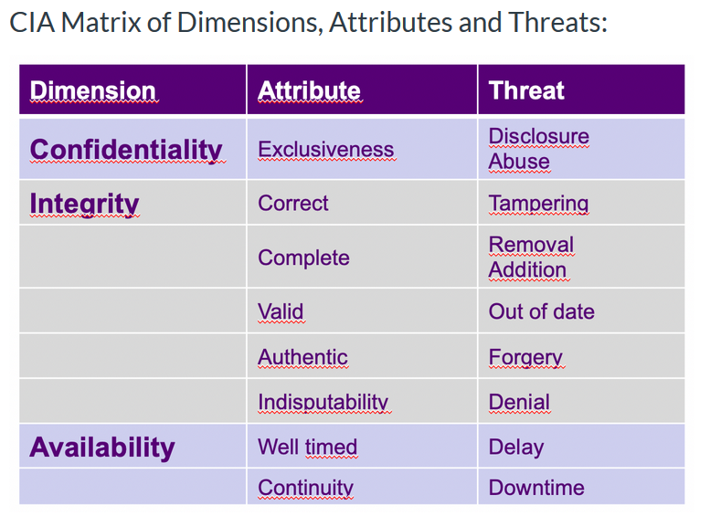

# Security incident management

Attackers try to breach the network by targeting unsecured ports, penetrating network security, or abusing network access.

1. **Alert reception:**

A security alert should come from the monitoring systems, or from a service desk. (reference security incident management, n.d.) From here the company can further analyse the alert and take action if the incident is a security incident.

**Best practices:**

Track connections to your network from the outside to detect intrusions, compromises, malicious software, and even users abusing network access.

Log network flow to record access to and from the internet.

Apply Network Behaviour Anomaly Detection and Network Behaviour Analysis.

So in my company the monitoring systems and operators in an Security Operations Centre (SOC) should detect an issue. When the attack happens, they will then start with the second phase.

2**. Alert Triage and prioritization.**

Triage is the first step to take, after first detection or reception of a security alert. In triage you gather information to be able to determine if the alert is a real incident or a false positive and what the severity and impact of the incident is. From that you determine the priority.  
There are 3 steps in the triage:

1. categorise the incident. How severe is it and what are the potential impacts?  
2. Prioritise. Does this require an urgent escalation, or can it be easily resolved?  
3. Assignment. Who is responsible managing and resolving the incident, and by when?

Traffic from compromised servers may leave distinctly visible patterns, which can be analysed for information or used to mitigate an attack. Identifying this type of traffic can help with the response of the company before data is lost or damaged.

3. **Respond:**

The response can have different types of communication which can all be important.

**The technical response:** This can include analysing the incident, advising on or planning a resolution, co-ordinating actions internally and externally, containing any on-going malicious activity, repairing or recovering any affected systems. With advice from your technology/service provider or accredited IT security consultant may be required.

**Management response:** focuses on activities such as notifying staff and affected customers of a breach and advising of steps taken to resolve the situation, approving courses of action and other communications.

**Legal response:** If the incident involves fraud or cyber crime you should report the incident to the police.

4. **Close the incident and review:**after the incident a review has to be done to see if any further actions have to be taken to minimize the risk of the incident occurring again.

**Attack 1: Network breach and database access.**

1. **categorise the incident. How severe is it and what are the potential impacts?**With the monitoring of the network through pre-setup applications, the SOC team will know that the network has been breached that the attackers have access to the database. Meaning it is very severe and the potential impacts are huge. Once they have access to the network and database, they could delete valuable data.

2. **Prioritise. Does this require an urgent escalation, or can it be easily resolved?**  
This problem would require an quick response since it can deal a lot of damage to the whole company and all of its users.

3. **Assignment. Who is responsible managing and resolving the incident, and by when?**This incident should be solved as fast as possible. The SOC team will inform, the people who maintain the database, the people who maintain the network and the lead of the applications/company. If any user data has been stolen, the company should also inform the police about the incident.

**Attack 2: Port scan detected.**

1. **categorise the incident. How severe is it and what are the potential impacts?**The problem is not severe at all since the scanning of ports itself isn’t something with a huge impact.

2. **Prioritise. Does this require an urgent escalation, or can it be easily resolved?**   
This is not an urgent problem at all since it is not really a in the short run. But it would be wise to keep the most important ports in check.

3. **Assignment. Who is responsible managing and resolving the incident, and by when?**

This incident can mostly just be neglected by the company.

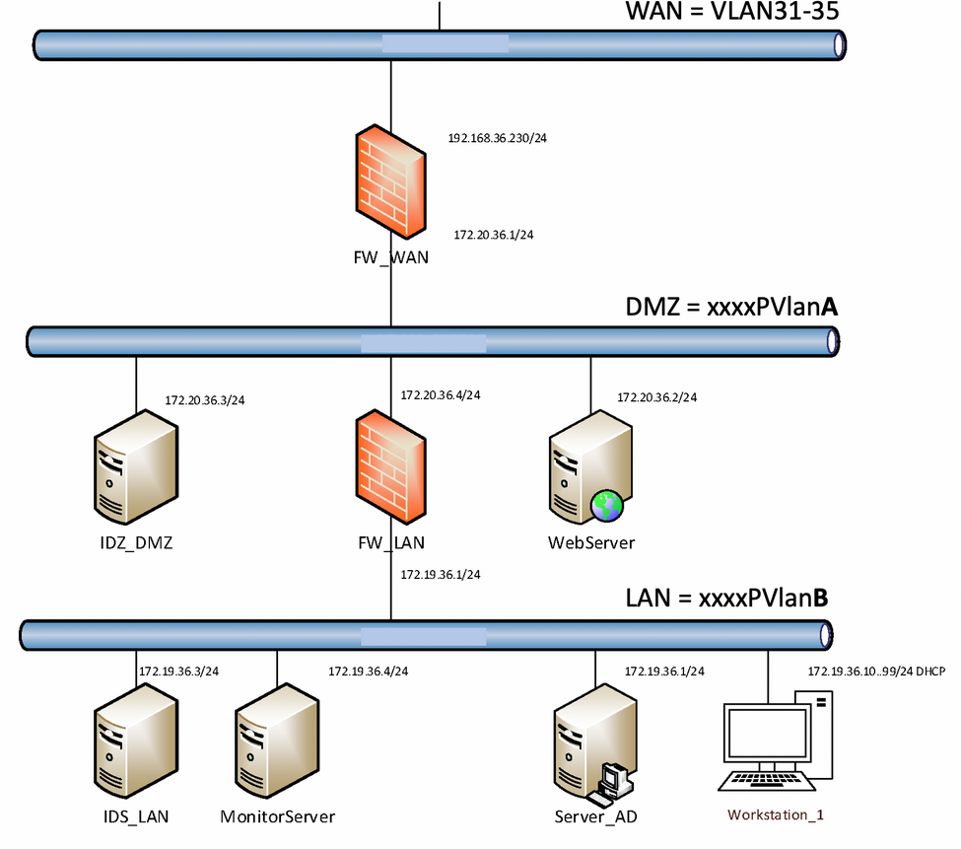

Firewall:

Opzet pfSense:

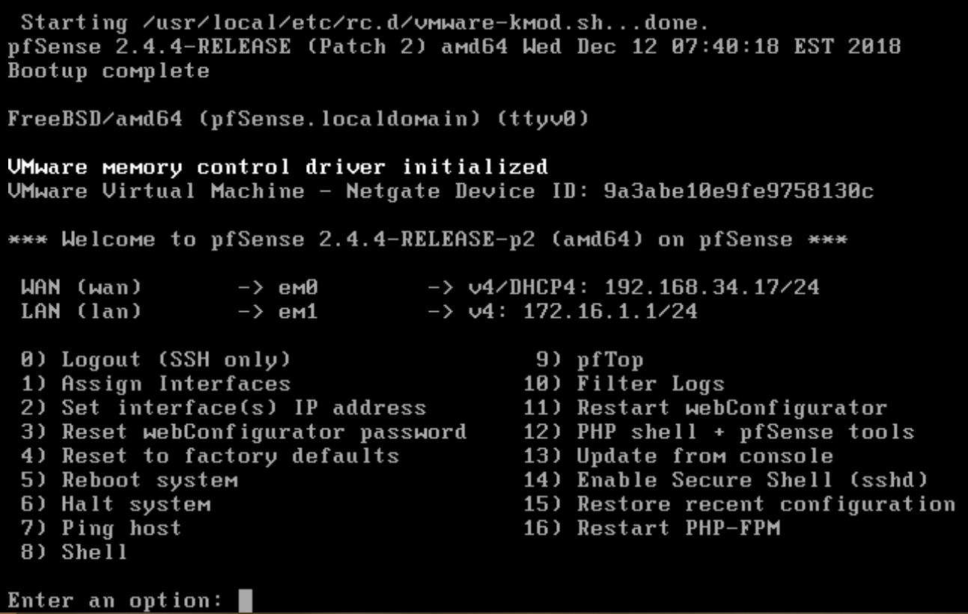

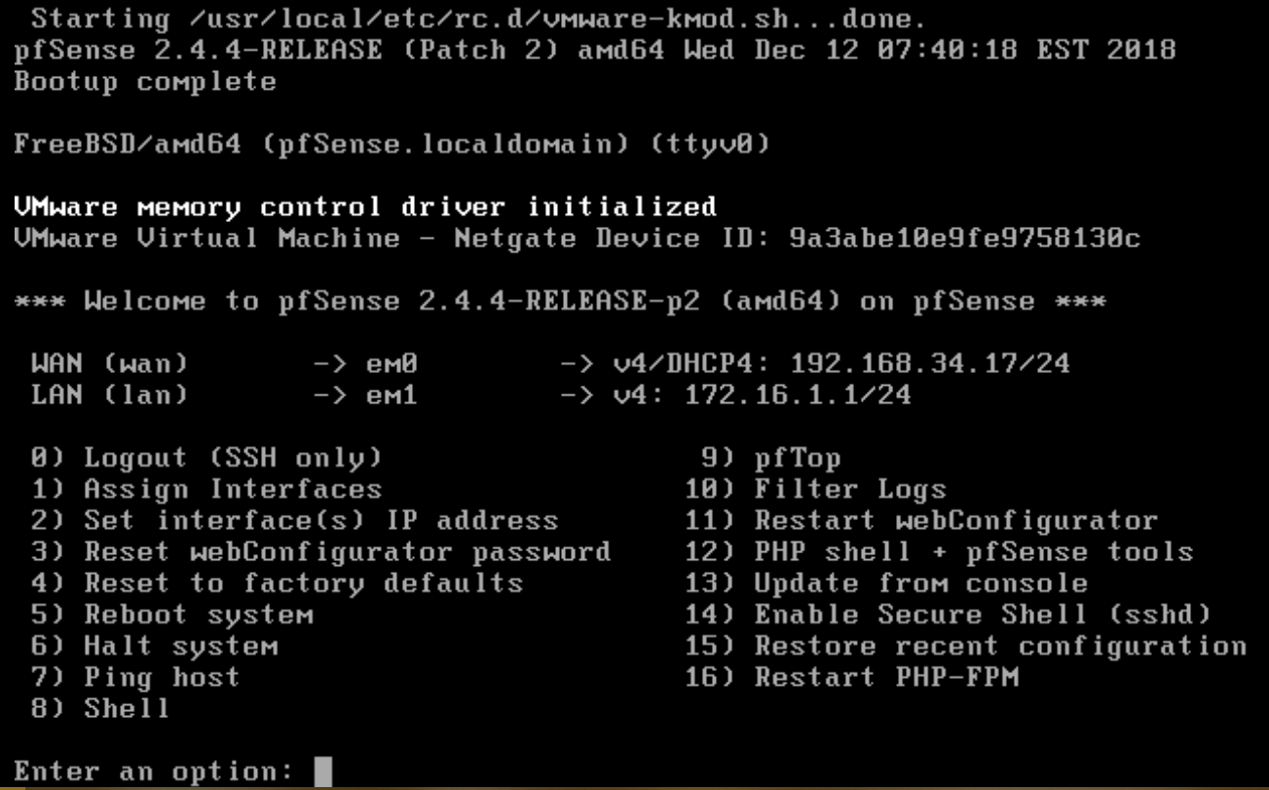

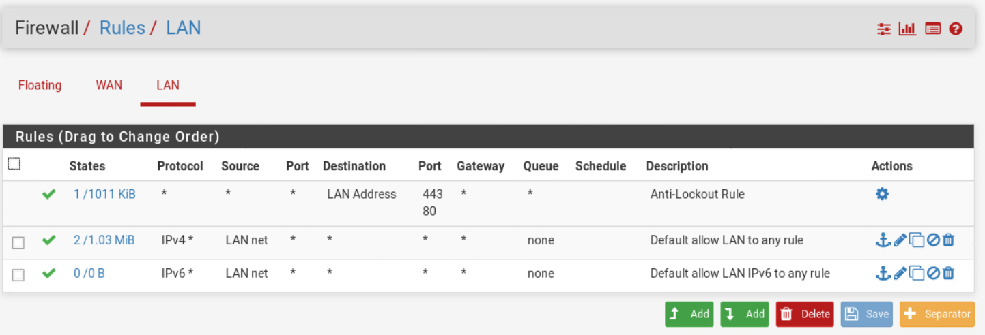

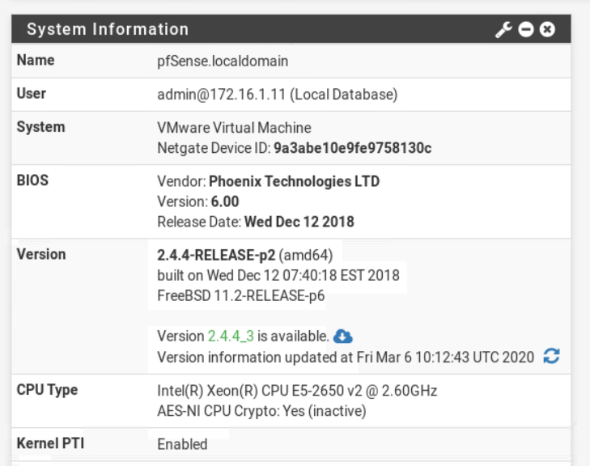

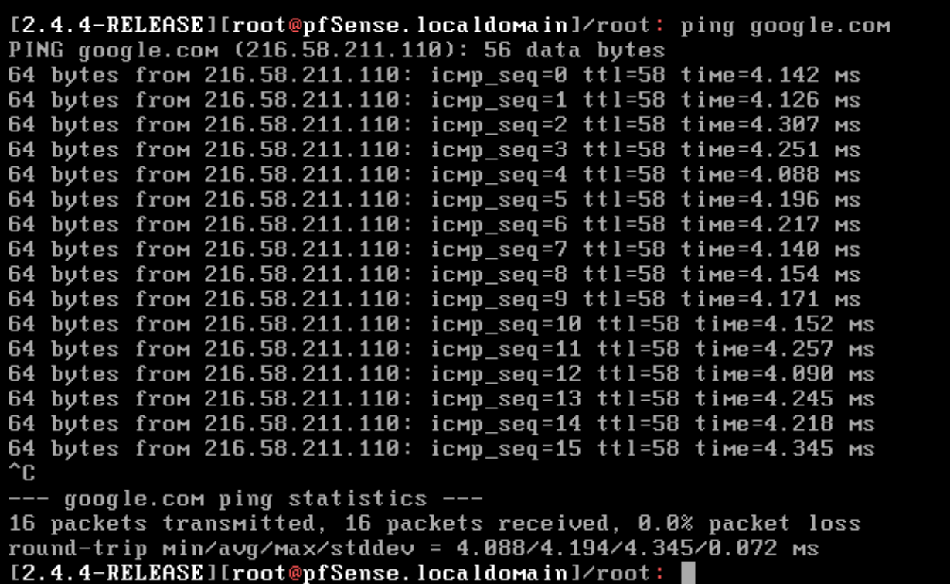

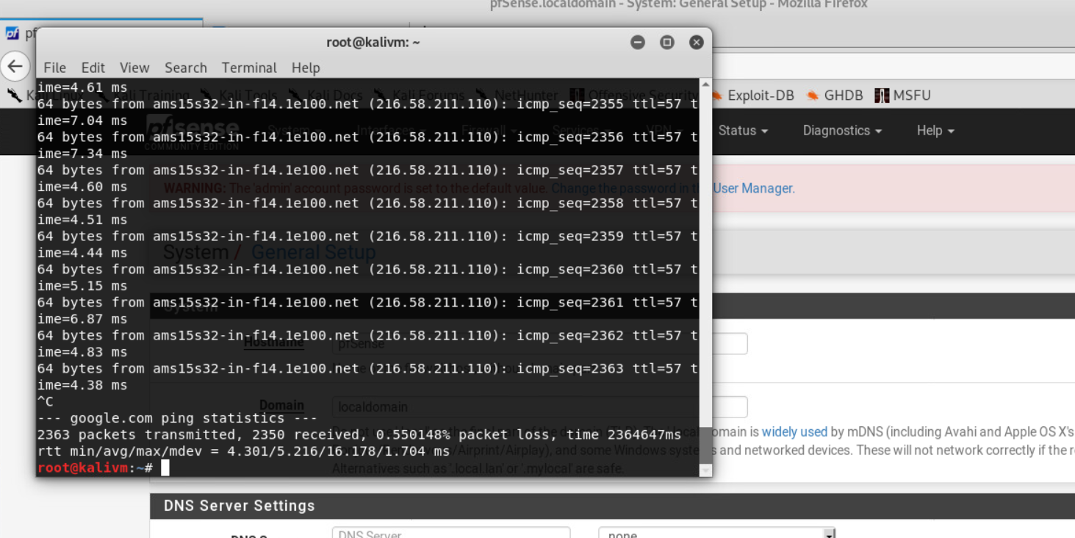

You can build your virtual network as visualised in the introduction of this document. You can obtain this by following this instruction

We start with configuring one firewall, and specifically the WAN interface (192.168.VLAN.xxx) and the LAN (172.16.xxx.xxx) interfaces of that firewall. For future expansion and debugging purposes, you want to write down the IP ranges and addresses you want to use in the table below.

|  |  |
| --- | --- |
| **IP configuration LAN and firewall** | |
| IP-range (subnet) LAN: | Breed |
| LAN ip-adres firewall: | 172.16.1.1 |
| WAN ip-adres firewall: | 192.168.34.17 |

## **Setting up pfSense firewall.**

For setting up a preinstalled virtual pfSense server, you can use a template available on the VMware environment:

* Using the **template “Templ_pfSense”** you can deploy your firewall system.
* To configure the firewall, we will use a workstation in the LAN during this practical assignment.
* Private_VLAN_PVlanA (is automatically visible to you in ESX for your account) for LAN (use some 172.16.*.* range)
* Private_VLAN_PVlanB for DMZ (use some other 172.16.*.* range or 10.*.*.*)
* For internet access (WAN) you need to connect to VLANxxx (192.168.VLAN.xxx range)

|  |  |
| --- | --- |
| **Deployment pfSense firewall and a workstation** | **Check** |
| 1. Deploy pfSense VM from latest template Templ_PFSense | Make sure your name is in the name of the VM |
| 1. Alter the virtual machine settings: Network adapter 1 (**WAN** network) Network adapter 2 (**LAN** network) | VLAN nr (SW_VLAN): 34 Private_VLANxxxx_A/B 2058 |
| 1. Deploy a LAN workstation from the template | Windows XP, 7, 8, ubuntu, debian |
| 1. Adjust the virtual machine settings to: Network adapter 1 (LAN network) | Private_VLANxxxx A/B ____ |

Boot the pfSense firewall. If everything works as it should, you end up in a command line menu, like in the picture below. If everything went well automatically, the WAN interface should be connected to em0 and LAN on em1 (eth0 and eth1 on Debian). If something went wrong, you can just redo option 1again. (If asked to setup VLANS, choose “no”, this is advanced stuff).

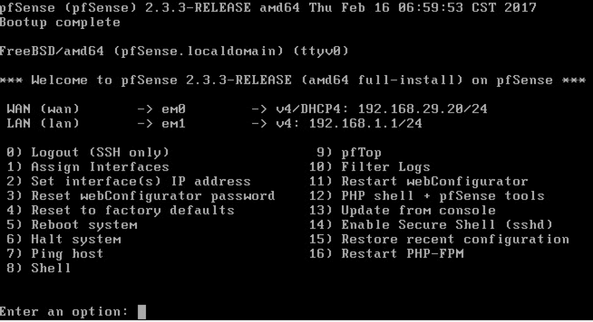

**Choose option 2 in the menu: Set Interface(s) IP address.**

*(Note: Using option 6 you can shutdown the system, but we advice pausing the virtual machine, it is faster. Shutting down a running virtual machine* ***can damage the image on the virtual machine****, so we recommend only to do this if you ran out of alternative options)*

Choose **"2 - LAN"** and make the following choices:

|  |  |
| --- | --- |
| Enter the new LAN ip-adres | Enter the earlier determined LAN ip-address of the firewall. |
| Enter the new LAN subnet bit count | 24 |
| Do you want to enable DHCP | Y(es) |
| Enter the new LAN IPv6 address | <ENTER> (none ipv6 config) |
| Start address client address range | <LAN range base>.11 |
| End address client address range | <LAN range base>.99 |
| Do you want to revert to HTTP as the webConfigurator protocol? | N(o) |

*By enabling DHCP the workstations in the LAN will automatically get the right ip-configuration (DHCP protocol.[1])*

**After changing the LAN settings, it is a good idea to reboot. Select "5 ) Reboot system".**

As written earlier, you can now further manage the firewall from the LAN by browsing the IP address of your firewall in a web browser.

|  |  |
| --- | --- |
| Boot the workstation in your LAN |  |
| Check whether the workstation has received IP settings. Write down:  - Which IP address does the workstation have?  - Which default gateway does the workstation have? |  |
| Open your browser (Internet Explorer?) and surf to **https://<ip-address firewall>**  **Accept the security warning (self-signed certificate)** |  |
| ou will now see the login screen of the firewall.  Enter the default access account:  User Name:  Password: | admin  pfsense |

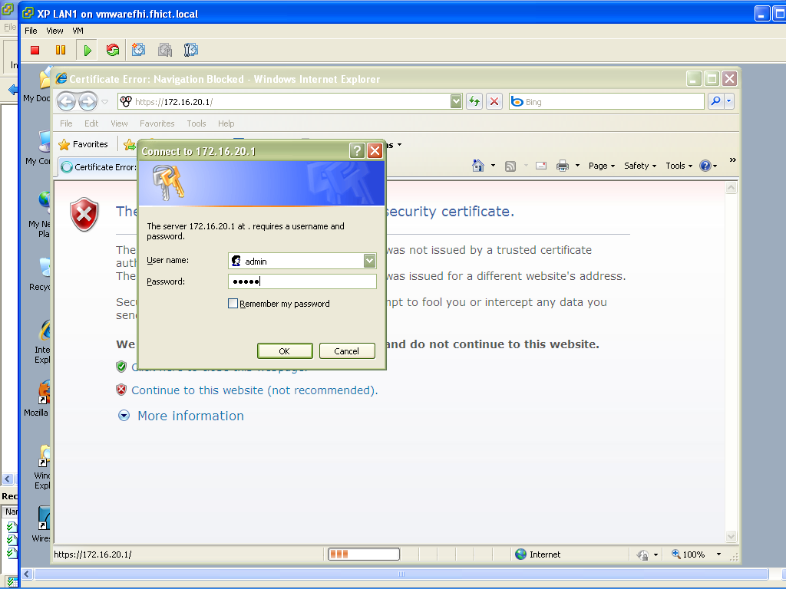

Now verifiy the setting:

* WAN (scroll down) at RFC918 and bogon networks and verify that the checkboxes are OFF !!

Enter what you have set below.

|  |  |
| --- | --- |
| Configure WAN IP-settings | |
| General Configuration - Type | Static / Dynamic |
| IP configuration – IP address: | 192.168.34.17/24 |
| IP configuration – gateway: |  |
| DNS server |  |
| Block RFC1918 Private Networks | Uncheck! |

In the menu, go to System - General Setup and adjust the password so that your firewall configuration is protected against other lab visitors:

|  |  |
| --- | --- |
| Configure General Setup | |
| Admin password |  |

Go through the menus in the firewall web console once to get an overview of the available functionality.

It should be possible to ping www.google.nl from the workstation.

You should also be able to browse e.g. http://www.google.nl on the workstation.

|  |
| --- |
| Add some screenshots of the pfSense firewall and the workstation as proof:   * Screenshot of Firewall: Rules (LAN and / or WAN interface) * Screenshot of the executed ping command (on the workstation) |
|  |

# **Packet filtering**

The basic filtering of each firewall is done by packet filtering. Incoming and outbound network packets are allowed or blocked based on their origin (ip address, internal / external network) and service / protocol (tcp / udp port number). For example, HTTP traffic (TCP port 80) is allowed on most internal networks towards the internet. This is necessary because otherwise it is not possible to 'surf the internet'. Only allowing HTTP traffic is not enough to be able to use the internet. Which protocols are also needed to browse the internet? Also enter the standard port numbers for these protocols

|  |  |  |
| --- | --- | --- |
| Internet protocollen om te kunnen browsen. | TCP / UDP | poortnummer |
|  |  |  |
|  |  |  |
|  |  |  |

For packet filtering, it is a good practice not to work with separate hard-configured IP addresses and port numbers, but to work with meaningful definitions.

Create a definition for "normal internet traffic". Write here all defined port numbers for normal Internet browsing:

|  |  |
| --- | --- |
| Define alias internet traffic | |
| Go to Firewall – Aliases |  |
| Add alias | Select “+” symbol |
| Fill in alias details:   * Name: * Description: * Type: * Ports: | Port(s) |
| Save + Apply changes |  |

*Now that we have a definition we can create a firewall filtering rule with this alias. Go to Firewall - Rules. View the default available rule at the LAN tab, explain what this rule does and why this rule is not desirable for a business environment. Remove the default rule.*

*Note: Leave the default WAN rule (about using private addresses).*

|  |
| --- |
| What is the use of the default LAN rule and why does it have to be removed? |
| Je will niet dat iedereen toegang heeft tot alles |

Now add a rule. Enter the correct values ​​for the fields given below. Leave the other settings untouched.

|  |  |
| --- | --- |
| Definition firewall rule | |
| Action | You can allow something to pass, block or reject. Difference between block and reject Is that with reject a packet (TCP RST or ICMP port unreachable for UDP) is returned to the sender, whereas with block the packet is dropped silently. In either case, the original packet is discarded. |
| Interface | The interface from wich packets must come to match this rule |
| Protocol | Which IP protocol this rule should match |
| Source – Type | Where it’s from |
| Destination | Where it’s going to |
| Destination port range | Enter the previously defined alias name in the red 'from' and 'to' fields. |
| Description | The description of the rule |

After save and apply changes, it should be possible to visit the internet with the workstation. Check whether this is indeed the case. Consider what the problem can be if it does not work and call in a classmate or lecturer if you can not figure it out.

|  |
| --- |
| Add some screenshots of the pfSense firewall as proof:  Screenshot of Firewall: Rules (both LAN and WAN interface)  Screenshot of the alias Firewall used: Alias |
|  |

It should be possible to ping www.google.nl from the workstation.

You should also be able to browse e.g. http://www.google.nl on the workstation.

To do this, the firewall must be set in such a way that ping traffic is also passed through. Find out which firewall rule(s) should be added.

# **Final notes**

In this workshop you have gained insight into the practical configuration of packet filtering, application level filtering and the setup of a basic firewall architecture. Use this knowledge to set up a firewall architecture for your project.

Do not forget to turn off your virtual machines at the end of this workshop. If virtual machines remain on, other students have less resources available on the seclab environment. **The rule is that you always switch off all virtual machines before you leave SecLab**. Endurance tests are only possible to a limited extent and with the permission of the lecturer.

**You can configure a static WAN address:**

* Set fixed (Static) IP address for WAN connection **> 100**, for example 192.168.<yourvlan>.<100+yournumber>
* Setting up the DNS server for the firewall (This is the DNS server of seclab on 192.168.200.14)
* Set gateway to 192.168.yourvlan.**1**

WAN alles naar buiten

Lan niks naar binnen

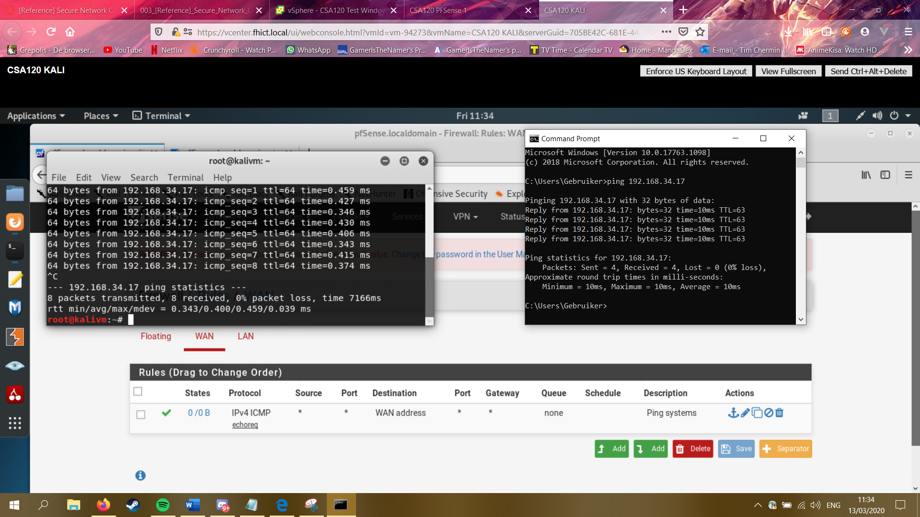

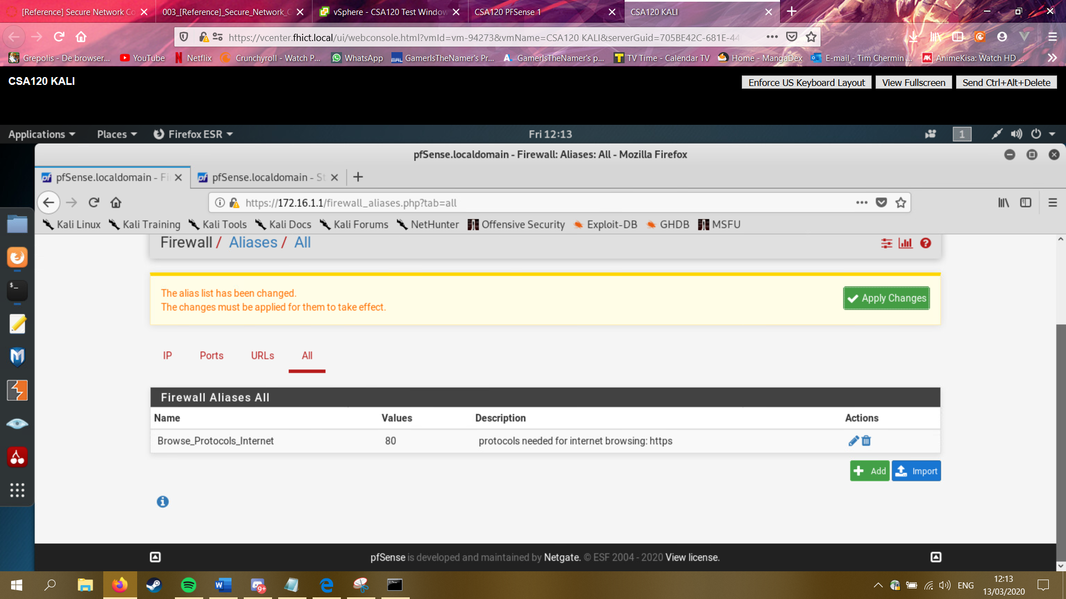

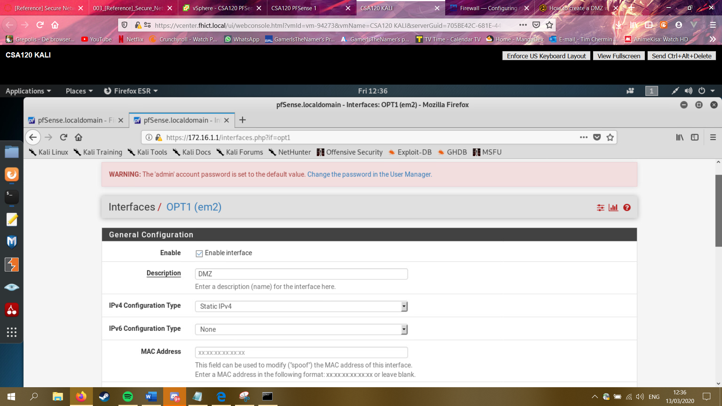

Before:

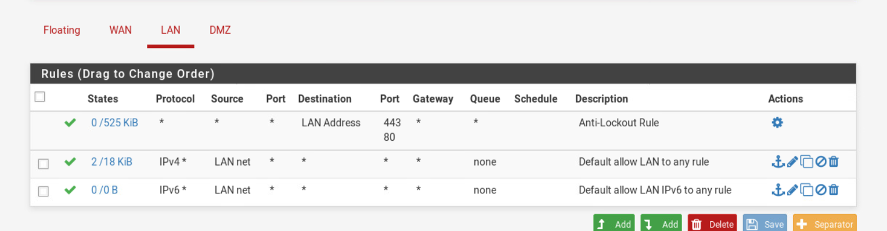

After

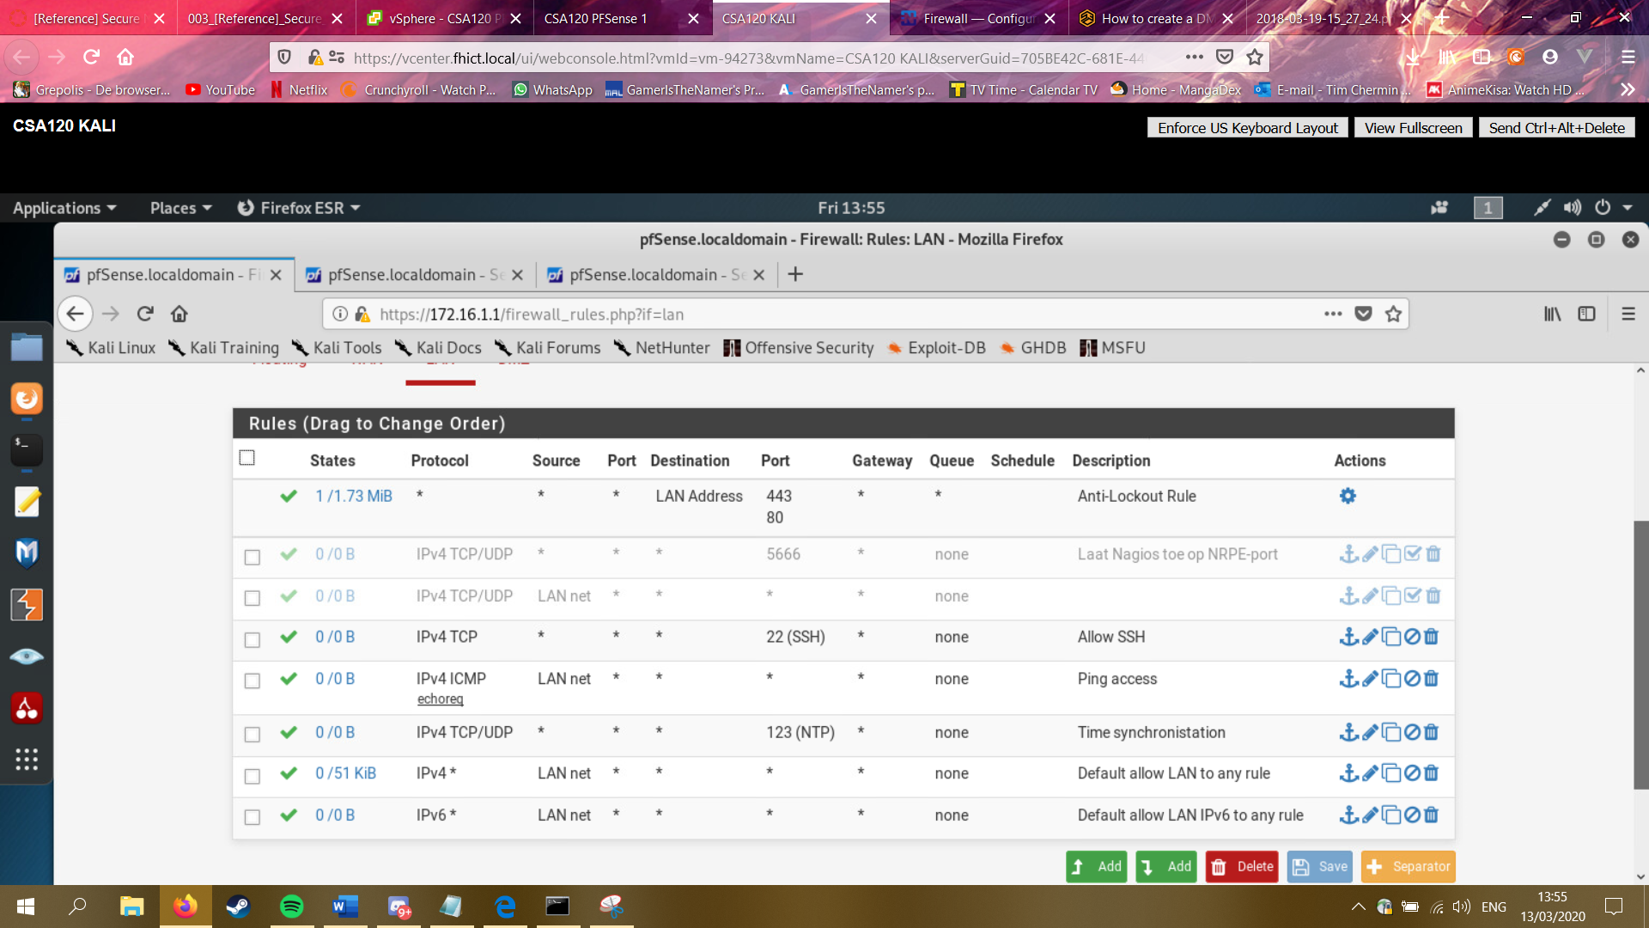

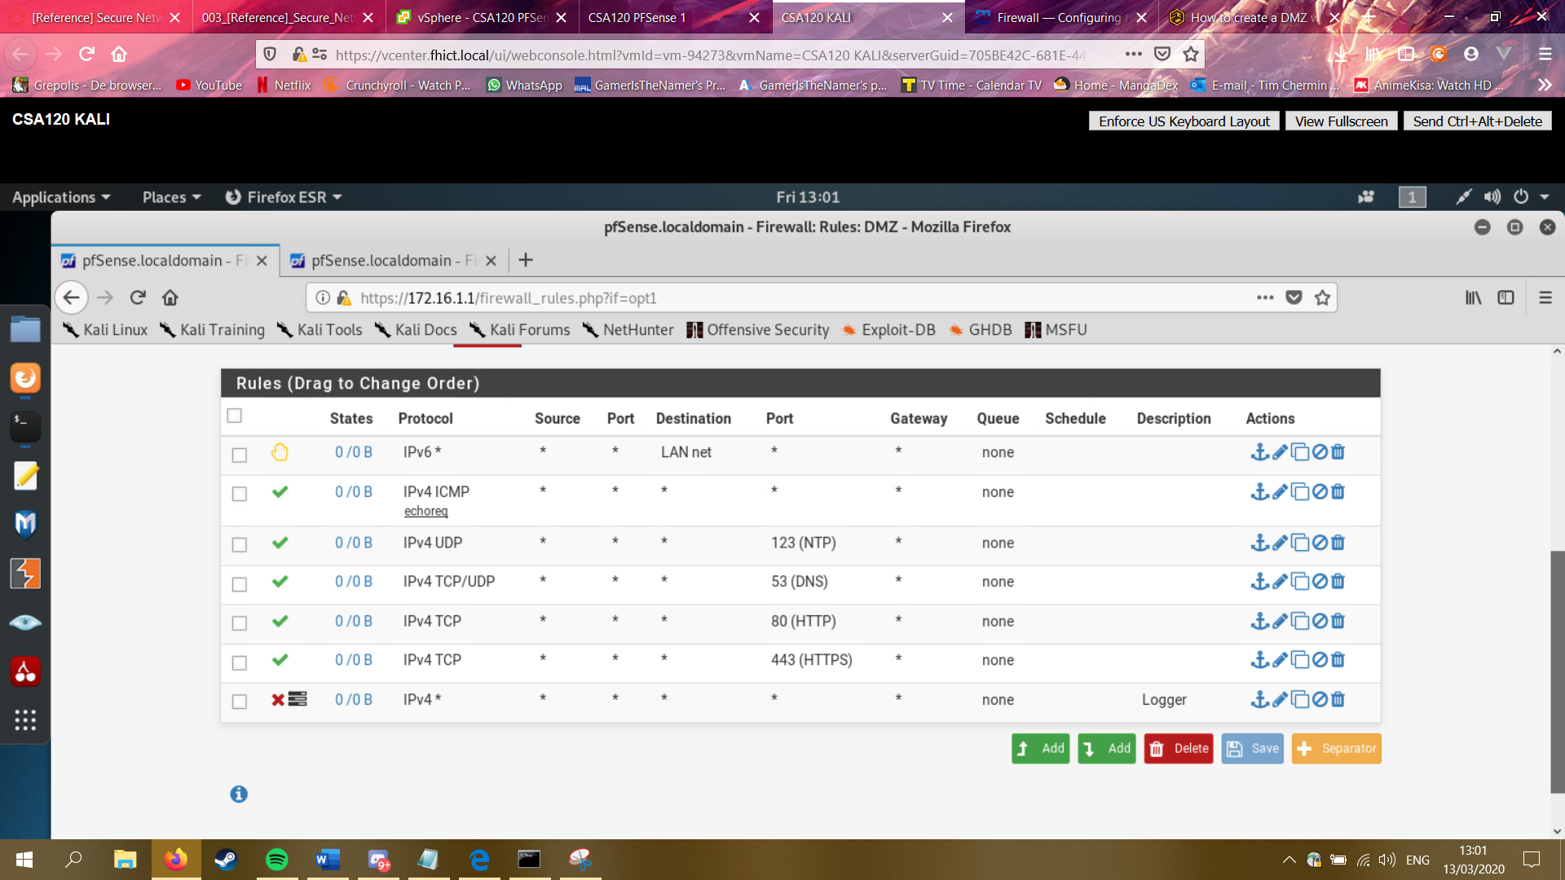

A DMZ is usually created if you want a more restrictive outside-facing part of your network that is separated from your internal network. A Web server would be a good example for this. You want the Web server to be reachable from the Internet, but you don’t want anyone from the Internet being able to also access your internal network.

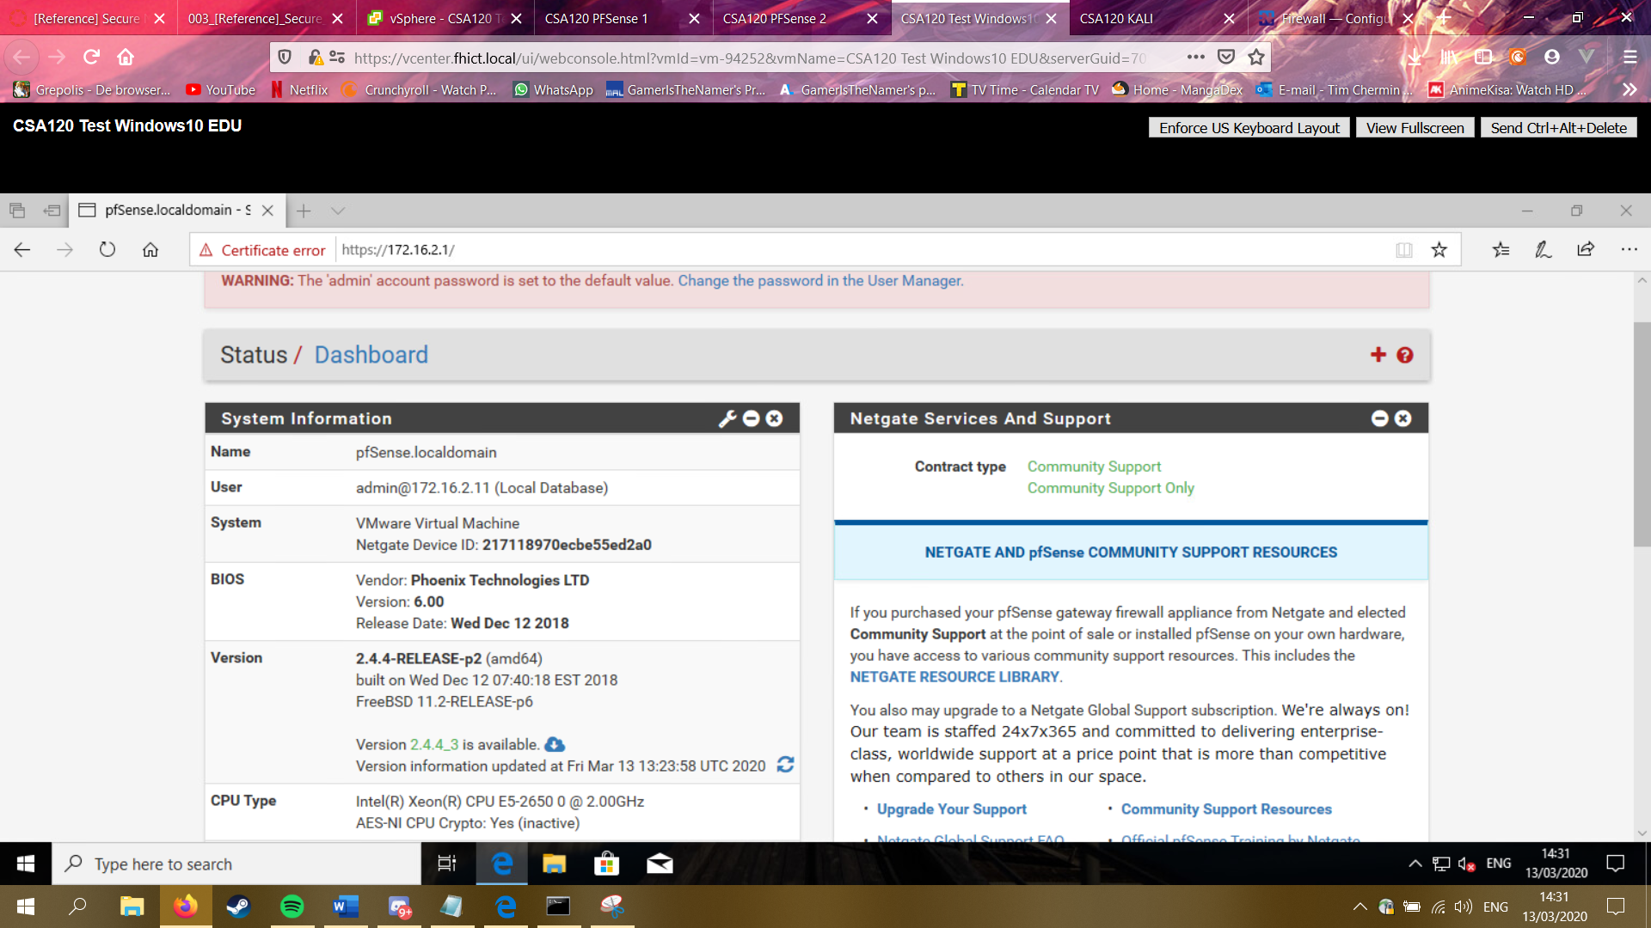

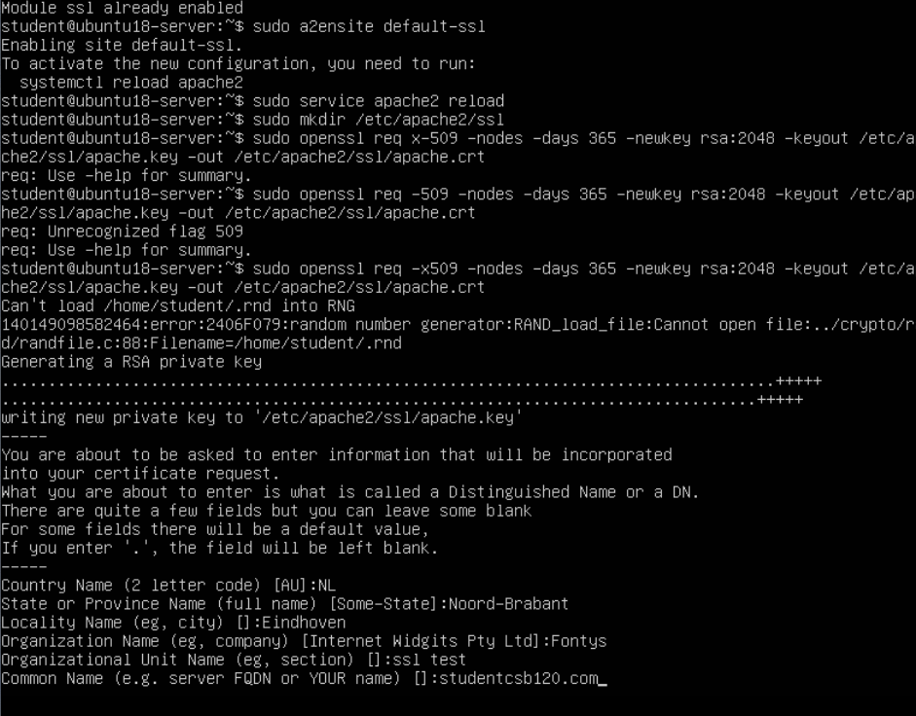

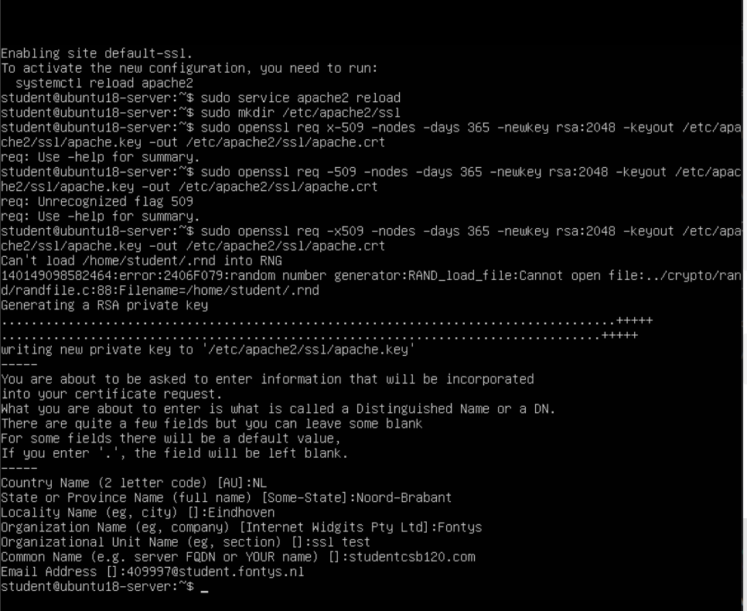

# Bibliography

*explanation basic knowledge assignment*. (n.d.). Retrieved from fhict.instructure: https://fhict.instructure.com/courses/9462/pages/explanation-basic-knowledge-assignment?module_item_id=466732

*reference security incident management*. (n.d.). Retrieved from fhict.instructure: https://fhict.instructure.com/courses/9462/pages/reference-security-incident-management?module_item_id=466743

# Notes for later

**Network separation:**

Why?

* Security omdat als er 1 gehacked zou worden dan is de rest nog niet gehacked.
* Performance als alles op 1 netwerk zit dan wordt t trager omdat alles broadcast.

Waar plaats je firewalls

1. between a local network and external networks

2. on gateways to important subnets within the LAN

3. End-points user-device/server

Een groter netwerk met meer firewalls betekend niet gelijk dat het veiliger is, als de firewalls niet sterk zijn of niet goed opgezet dan kan het weinig nut hebben.

DMZ: zit een webserver in die met de buitenkant praat.

**Internal examples:** Data center, extranet, remote access, lab, desktop, wireless.

**External:** DMZ, server data center, remote access, test or staging, internet.

**Firewall rules/policies:** DMZ only accessible from the outside, not connected to internal network.

2 kinds of firewalls: **Stateless:** firewall filter, also known as an access.

**Stateful:** firewalls can watch traffic streams from end to end. Firewall might know what the intensions of the user is.

**Next-generation firewall:** NGFWs typically feature advance functions including: application awareness, integrated intrusion prevention systems, identity awareness – user group control.

**Secure connections met crypto:**

Modern crypto: Password hasing, secure connections and transactions/commnications, encrtyped wifi, disk encryption, digitale signatures, digital money, cars.

Symmetrical encryption sender and receiver use the same key

Asymmetrical encryption: every user has a keypair consisting of a

public key

1. used for encryption.

2. check signatures

A private key:

1. used for decryption

2. place signature (signen)

**Never design your own crypto**

1. Only use DHCP on private networks, never on interfaces connected to the “normal” VLANs of seclab. This could conflict with the seclab DHCP service and disable DHCP for other students on the same VLAN.